Kajiado North Land Valuations
Analysis of the 2022–2023 valuation register
Source file: Kajiado North 2022-2025.xlsx · Prepared 12 October 2026

1. Executive summary
This report analyses a register of land valuations for Kajiado North. The workbook is titled 2022–2025, but it only holds data for 2022 and 2023: the 2024 sheet is empty and there is no 2025 sheet. After cleaning, 2,717 records remain, and 2,346 of them have a usable valuation.
- Typical value is stable. The median valuation was KSh 1.5 million in both 2022 and 2023, and the middle half of values ran from about KSh 0.4–0.5 million to KSh 4.4–5.0 million.
- Ngong dominates. Ngong accounts for 35% of all valuations and has by far the highest values: a median of KSh 4.5 million in 2023 and about KSh 24 million per acre. That is roughly ten times the per-acre value in Ntashart, Kipeto and Loodariak.
- Most parcels are small plots. About 59% of parcels with a recorded area are 0.05 ha (⅛ acre) or less. The most common size is 0.045 ha, the standard 50 × 100 ft plot.
- Price per acre falls steeply with size. Plots of 0.05–0.1 ha have a median of about KSh 13.5 million per acre. Holdings over 5 ha have a median of about KSh 64,000 per acre.
- Data quality is the main limitation. Registration sections are spelled inconsistently, many values are ditto marks, 2022 areas are mostly missing, there are entry errors, and 82 parcels are duplicated within a year. These issues limit the comparison between years in particular.

2. Data source and scope
The workbook has one sheet per year. Each sheet has six columns: Registration Section (parcel number), Area (Ha), Valued (KSh), Situation (location notes), Remarks and an unnamed date column. The entries appear to be transcribed from handwritten records.
Sheet | Records | Usable values | Areas recorded | Dates recorded
2022 | 1,365 | 1,098 | 339 (25%) | None
2023 | 1,352 | 1,248 | 1,326 (98%) | 396 (Jan–Dec 2023)
2024 | 0 | – | – | –
2025 | No sheet | – | – | –
Table 1. Records per sheet after removing fully blank rows.
The Remarks column is empty in every row. The Situation column has short, often partly illegible location descriptions (for example, distance from a road or landmark), so it was not used in the quantitative analysis.

3. Method
The data were cleaned in Python (pandas) as follows:
- Blank rows removed: rows with no parcel number, area or value were dropped.
- Values standardised: commas were removed, "2M"-style entries were converted to full amounts, and ditto marks (") were replaced with the value in the row above. Non-monetary entries such as "GIFT", "[unclear]" and per-acre rates were set to missing.
- Areas standardised: suffixes such as "HA" and stray punctuation were removed, and areas recorded in square metres were converted to hectares (÷ 10,000).
- Registration sections normalised: county prefixes (KJD, KJO, Kajiado) were stripped, and spelling variants were matched to a list of known sections by fuzzy matching (for example NTASHARI, NTAJHART and MTASHART all became Ntashart). Sections that could not be matched were grouped as "Other".
- Implausible values excluded: values under KSh 1,000 (usually an area typed into the value column), values over KSh 5 billion (one entry of about KSh 4 trillion) and areas of zero or less were set to missing.
- Value per acre derived: value ÷ (area in ha × 2.471), for parcels with both a value and an area.
Medians are reported throughout instead of means, because the values are heavily right-skewed. For example, the 2022 mean is KSh 3.7 million against a median of KSh 1.5 million.

4. Findings

4.1 Overall distribution
Statistic (KSh) | 2022 | 2023
Valuations | 1,098 | 1,248
Median | 1,500,000 | 1,500,000
Mean | 3,676,000 | 3,485,000
Lower quartile | 500,000 | 400,000
Upper quartile | 4,375,000 | 5,000,000
Maximum | 195,000,000 | 110,000,000
Median area (ha) | 0.045 | 0.050
Table 2. Distribution of valuations by year.
The overall picture is almost identical across the two years. The upper quartile rose from KSh 4.4 million to KSh 5.0 million, but this reflects a different mix of sections as much as any price change (see Section 5).

4.2 Values by registration section
Five sections account for about three-quarters (76%) of valuations. Their medians are shown below.
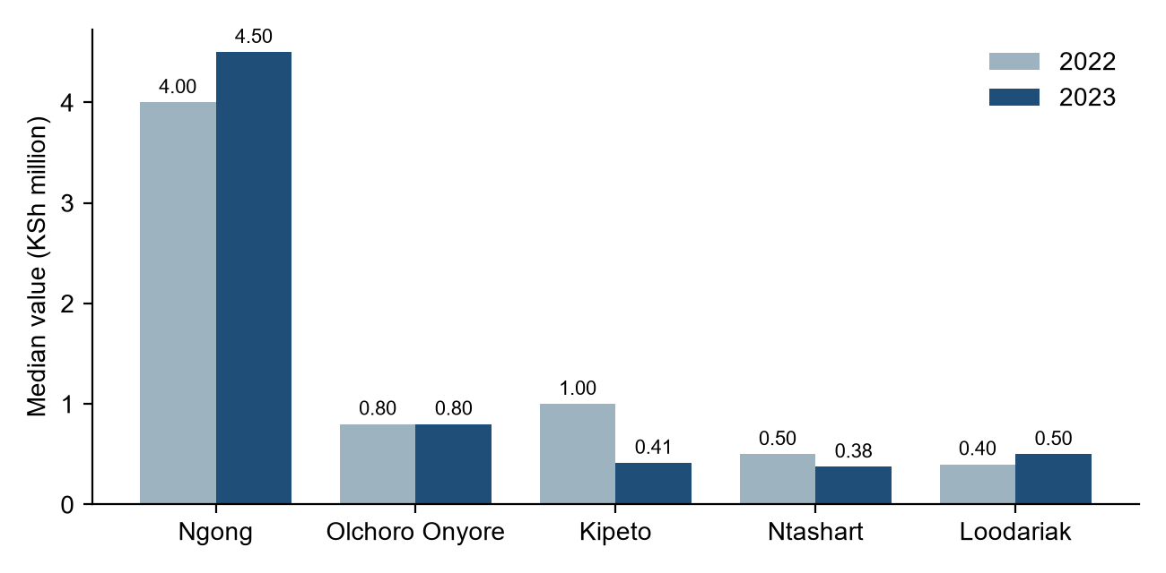
Figure 1. Median valuation by registration section and year (KSh million).
Section | n 2022 | n 2023 | Median 2022 | Median 2023 | Median / acre 2023
Ngong | 375 | 449 | 4,000,000 | 4,500,000 | 24,161,000
Ntashart | 230 | 310 | 500,000 | 375,000 | 2,409,000
Olchoro Onyore | 55 | 114 | 800,000 | 800,000 | 4,047,000
Kipeto | 77 | 52 | 1,000,000 | 414,000 | 2,370,000
Loodariak | 57 | 57 | 400,000 | 500,000 | 1,012,000
Olekasasi | 20 | 23 | 6,250,000 | 3,700,000 | 23,382,000
Oloore | 48 | 1 | 625,000 | 800,000 | –
Ewaso Kedong | 13 | 21 | 1,000,000 | 30,000 | 190,000
Other / unmatched | 201 | 168 | – | – | –
Table 3. Valuations by section (KSh). Per-acre figures are shown for 2023 only, because few 2022 records have an area.
Ngong, the most urbanised section, is clearly the most valuable: its median per-acre value is about ten times that of the peri-urban and rural sections of Ntashart, Kipeto and Loodariak. Olekasasi has similarly high per-acre values but only about 20 valuations a year. The Ewaso Kedong figures come mostly from large rural holdings and are based on few records.

4.3 Effect of parcel size
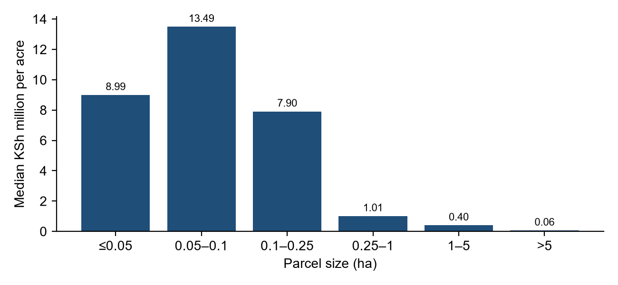
Figure 2. Median value per acre by parcel size band (KSh million).
Parcel size (ha) | Valuations | Median value per acre (KSh)
≤ 0.05 | 886 | 8,993,000
0.05 – 0.1 | 260 | 13,490,000
0.1 – 0.25 | 91 | 7,904,000
0.25 – 1 | 143 | 1,012,000
1 – 5 | 76 | 399,000
> 5 | 51 | 64,000
Table 4. Value per acre by size band (both years combined).
Per-acre value falls sharply above a quarter of a hectare. Small plots are concentrated in Ngong and other urbanising areas, while large holdings are in rural sections, so this pattern reflects location as well as size. Total value is only weakly related to area (correlation of log value with log area = 0.17). This is partly because some valuations include buildings: about 60 records mention houses, apartments or structures.

4.4 Highest valuations
The ten largest valuations range from KSh 50 million to KSh 195 million. Most are in Ngong. Several have no recorded area, and one (Olekasasi/189, KSh 110 million, 3.19 ha) is described as a lodge. Before these values are used in modelling, they should be checked against the source documents.

5. Data quality issues
Issue | Extent | Treatment / impact
Inconsistent section spelling (KJD/KJO/KID; NTASHART/NTASHARI/MTASHART; LOODARIK/LOODARIAK) | Widespread | Fuzzy-matched; about 370 records left as Other/Unknown
Ditto marks (") instead of values or areas | ~60 values, ~21 areas | Filled from the previous row
Mixed formats ("2M", "0.19 HA", "75m2", "40,000 per acre") | ~200 cells | Parsed where unambiguous; otherwise set to missing
Missing areas in 2022 | 75% of rows | Per-acre analysis effectively limited to 2023
No dates for 2022; partial dates for 2023 | All of 2022; 71% of 2023 | No within-year trend analysis possible
Duplicate parcels within a year | 82 records | Retained; some have conflicting values (e.g. Kipeto/3691)
Implausible entries (value of KSh 4 trillion, areas of 0 or 809 ha) | A handful | Excluded
Land and buildings not distinguished | Unknown share | Inflates values for some small plots
Remarks column empty; Situation text partly illegible | All rows | Not used
Table 5. Summary of data quality issues.
The year-to-year comparison is affected most. Changes in medians (for example, Kipeto falling from KSh 1.0 million to KSh 0.41 million) may reflect which parcels happened to be valued each year, not real price movements.

6. Conclusions and recommendations
- Land values in Kajiado North follow a clear gradient: highest in Ngong and Olekasasi, lower in Olchoro Onyore and Oloore, and lowest in the rural sections of Ntashart, Kipeto, Loodariak and Ewaso Kedong.
- Small subdivided plots (⅛ acre) make up most transactions and have the highest per-acre values.
- The register cannot yet support a reliable estimate of price growth between 2022 and 2023.
Recommendations
- Standardise registration sections at data entry using a fixed drop-down list of sections.
- Make area and valuation date mandatory fields, and record area in a single unit (hectares).
- Add a field showing whether a valuation includes buildings, and if possible the land and improvement values separately.
- Check duplicate parcels and the largest outliers against the original valuation records.
- Complete the 2024 and 2025 sheets, so that trends can be analysed over the full period the workbook is named for.
- For future analysis, compare like with like: use median value per acre within each section and size band, and consider a hedonic regression controlling for section, size and buildings.

